Herry Putter Capstone Planning Document

The Concept:

For my Capstone Project, I will be recreating the process of finding your Haugwarts house. This is intended to inspire the emotion of excitement (joy/fear). For reference, here is the complete story:

At the start, the user will first get to travel to Haugwarts from 9 3/4ths, put on the sorting hat in the grand hall, and fight or flight with a Troll to prove that you were really meant for the house you wanted. I was inspired by this idea when I took the Pottermore House test online, and found it lacking a necessary component of “testing” to see which you should be placed in. Action to back up your words. Before VR, there really hadn’t been a means to take this next step. And I found no such experience yet, so decided to build it out as creating it could encompass a number of unique VR components (like Speech Recognition, Magic/Physics Mechanics, and the ability to relive the story through First Person perspective (currently only available through Disneyland).

The actions required by the user will be (all highly envied HP fan moments):

Running through Stations Brick Wall

Moving to and placing the Sorting Hat on their head

Responding Verbally to Sorting Hat question

Fight/Flight with the Troll (attack the troll, or collect the treasure and run)

Based on the collected data, they will receive their House placement. End.

Features And Dependencies:

* 3D Models + Animations (Reference Images)
* Intro Scene Door - To Hall (Revised: Train Tunnel Archway)
* 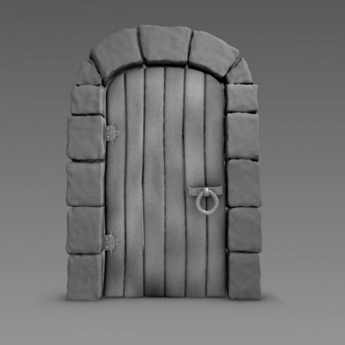
* 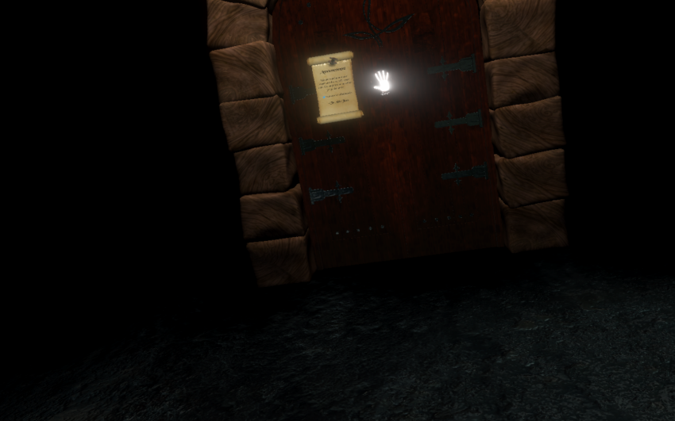
* Little Wizards/Witches
* 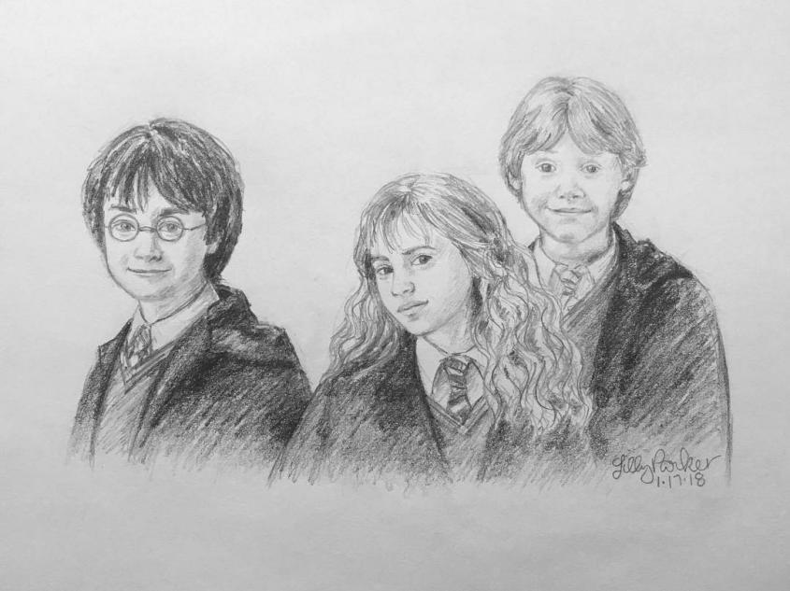
* Hogwarts Castle Interior (Grand Hall) & (Minor Hall)
* Interactable House Crests
* 
* Train Tunnel Archway
* 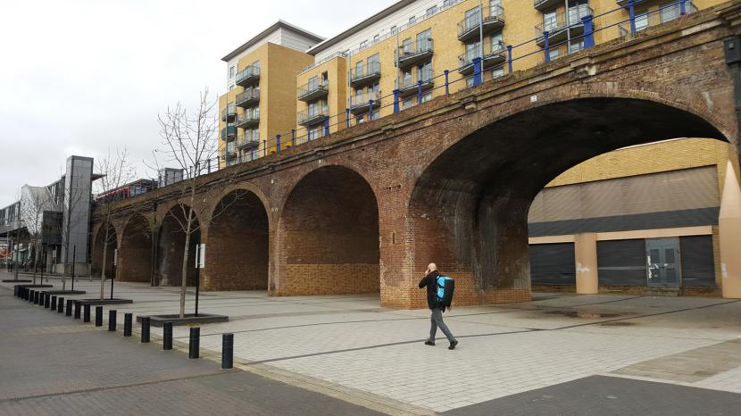
* 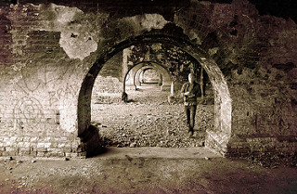
* 
* Wooden Stool
  + - NA - From memory
* Game Loop
* Player is situated in loading screen - wand mechanics work, practice spells on objects
* Scene 1 Loads to Grand Hall - One Person duplicated to create crowd, sorting hat situated at end of Grand Hall
* Player can move to hat
* Hat animated to instruct player
* Player puts on hat - screen goes black
* Scene 2 Loads to Black, Hat asks question (subtitled)
* User answer (Speech recognition - 4 one word answers)
* Hat details 3 magical objects and their great value (still black)
* Scene 3 Hallway - Footstep pounding - 3 objects glowing on table
* Troll turns corner heading towards you
* Hat asks user: which will you save from the troll?"
* User either responds "Accio [Object] OR fights troll "windgardium leviosa"
* Incorporate wand movement requirement?
* Scene 4 - House symbol appears on scene (showing your determined house)
* User gets to take object with them to their Oculus/SteamVR Home?
* Replay button
* Other Effects
* Add Harry Potter Theme Music
* Particle Effects at end of wand to inform user spell has worked?
* Sound effects: Troll footsteps, Spell sound, Troll roar, achievement sound
* Vocal recordings: (Danny) 1. Hat dialogue
* Procedural nav mesh to have troll walk to you (or line animation?)
* Objects Glow - to attract user focus
* Hat talking animation (& floating effect?) - or just on stool
* Wand glow (when successful cast) or line connecting to object

Example Capstone Scoping

Features And Dependencies:

* 3D Models + Animations
* Sorting Hat (talking)
* No revision
* Babbel, Wand - stuck to hand (choose lefty or righty)
* No revision
* Crowd Person (shuffling)
* **Revised: not enough time to create**
* Troll (walking)
* **Revised: NA**
* Dungeon: Use Udacity Term 1 Dungeon
* **Revised: Use Asset Store “Grand Hall”: <https://assetstore.unity.com/packages/3d/environments/historic/throne-hall-medieval-114784>**
* Game Loop
* Scene 1 Player is situated in loading screen - wand mechanics work, practice spells on objects
  + Revision: Unsure how interactable to make (require key to unlock?) + Fireworks + BrickArchway + Cart
  + Revision 2: Make them glow. Make the Crests fly around using (AddForce xyz), after the first crest has been collected? (too hard? Too soon?) Only if repeating the experience? (making it harder this time)
* Scene 2 Loads to Grand Hall - One Person duplicated to create crowd, sorting hat situated at end of Grand Hall
  + Revision: Crowd took to long to create, hat kept
* Player can move to hat
* Hat animated to instruct player
* Player puts on hat - screen goes black
* Scene 3 Loads to Black, Hat asks question (subtitled)
* User answer (Speech recognition - 4 one word answers)
  + No Revision
* Hat details 3 magical objects and their great value (still black)
  + Revision: Text, not audio (audio issues playing)
* Scene 4 Hallway - Footstep pounding - 3 objects glowing on table
* Troll turns corner heading towards you
* Hat asks user: which will you save from the troll?"
  + Revision: In previous scene, reminder using text
* User either responds "Accio” To grab an object OR fights troll "wingardium leviosa" or “stupify”
  + Revision: has to club troll with “wingardium leviosa” or “stupify”
* Incorporate wand movement requirement?
  + Revision: No, took too long
* Scene 4 - House symbol appears on scene (showing your determined house)
  + No Revision, more detail: Collect player response + player action = house
  + Revision: Currently determines your house by the action collected, not the answer collected
* User gets to take object with them to their Oculus/SteamVR Home?
  + More detail: TBD
* Replay button
  + Revision: Left out so that users can’t get all houses
* Other Effects
* Add Harry Potter Theme Music
  + Revision: No
* Particle Effects at end of wand to inform user spell has worked?
  + Revision: Completed
* Sound effects: Troll footsteps, Spell sound, Troll roar, achievement sound:
  + Revision: No
* Vocal recordings: (Danny) 1. Hat dialogue
  + Revision: Full production recording not completed, simply using self recording for completion purposes
* Procedural nav mesh to have troll walk to you (or line animation?)
  + Revision: No, animate path
* Objects Glow - to attract user focus
  + More detail, need brick to shimmer?
* Hat talking animation (& floating effect?) - or just on stool
  + Revision: Talking animation, no floating animation

**Script Dialogue (Not Yet Incorporated):**

Voice - Dumbledore

[Intro]

Talking: "You can't enter unless you know about Haugwarts! Collect the house crests to learn."

Collects the House crests that are zooming around.

If past 1 minute: "Thats enough, the way is open. Come along young witch, young wizard."

[Each Time a crest is collected, audio one of 4 audio pieces begins]

Talking (4 pieces):

HufflePuff backcard:

"You might belong in Hufflepuff,

Where they are just and loyal,

Those patient Hufflepuffs are true,

And unafraid of toil" -Sorting Hat

Gryfindor backcard:

"Where dwell the brave at heart, their daring, nerve and chivalry set Gryffindors apart."

Slytherin backcard:

"Or perhaps in Slytherin,

You'll make your real friends,

Those cunning folk use any means,

To achieve their ends" -Sorting Hat

Ravenclaw backcard:

"Or yet in wise old Ravenclaw,

If you've a ready mind,

Where those of wit and learning,

Will always find their kind."

Voice - Sorting Hat

[Grand Hall]

Talking: "Hey, Over here. Would you like to know which Haugwards House you belong in? Yes, yes, that's it, simply follow the red carpet to me, and pick me up. Go ahead, pick me up and put me on your head!"

**ALSO [alternative]:**

**Sing:**

**[Sorting Hat Song, found [here](https://genius.com/Jk-rowling-sorting-hats-song-1-annotated).]**

[Dark Scene]

Question 1: "Hmmm Difficult, very difficult. Perhaps a question then. Given the choice, would you rather invent a potion that would guarantee you [Glory], [Wisdom], [Love], or [Power]?

Go ahead, don't be shy. **Speak** the truth.”

Question 2 Follow-Up: "Now for the true test.

Haugwards holds dear several irreplaceable items and treasures, including a cure for [Dragon Pox], which the headmaster nearly perfected; [student records] going back 1000 years and a mysterious [handwritten book] full of strange runes, believed to have belonged to Merlin. Which will you save? Prepare yourself."

[enter Troll/White Cylinder scene]

Voice - Sorting Hat

Comment 1: “Almost got em’. Just missed!”

Comment 2: “Ohh, you’ve chosen to fight, and with the troll’s own club I see. Go ahead, you know what to do.”

Comment 3: “Wise choice”

House Selection:

“Gryffindor!”

“Slytherin!”

“HufflePuff!”

“RavenClaw!”

For Self-Reflection-

What we did today (deepdive):

-1) turned off fireworks start code, but used same time based methodology & current scene detection to pull and play audio for the sorting hat questions.2) set up multiple instances of audio only playing if the user had already chosen an answer 3) set up speech recognition, editting an existing code not to redirect an objects direction, but instead to store the word said for use later when determining their correct house, 4) set up script that will store various variables resultant from each scene, so that the results carry over, making sure its not destroyed by using donotdestroy code, but using it efficiently by inserting it (since its a get component) into the “on unload” code, so that it only is called when the level is unloading (and shifting to the next scene 5) made the hat contain a collider that when put on the users head (hits a trigger childed under the left eye anchor teleports the user to the next scene.6) built out a couple more scenes (1 for the hat questioning in dark 2 for the hallway fight so I can start building the code for it despite the objects not yet being there…first time ive built out the code before having the scene finsihed…might be going slower than usual because of it, but in the long run, I think im wasting less time? If that makes sense. 7) when summed up like this…it really doesn’t seem like I had “breakthroughs,” except the speech recoginition (which was more like a copy paste…that you could comprehend), but these things were all essentail elements, so they had to be done. But you were having so much fun that you let yourself take longer than necessary, and you didn’t eat for a few hours of it that made those hours extremely inefficient. Notes to self.

Voice Recog Day:

1. Created timers so once word was said, it would reset (deactivating the spell, particle system, functionality, etc) after a determined amount of time. 2) Set up a connection to pull from Speech Recog, and setting it as an if statement to replace the button actions that activated specific (wingardium leviosa or accio) spell functions. 3) Modified the original Speech Recog to reset the “word” immediately after it was said, however this did not cause any issues because in update the Spell script captured and stored that spell name, using it until time ran out and was reset within the spell script. (this was likely the most difficult solution to arrive at as I only had a general understanding of the Speech Recog script (enough to process and reshape it), but further modifications to me were risky. So my first 4 attempts were to change the spell script, but once those proved fruitless, “if only the impossible remains”(Holmes). Pretty success ridden day because it proved Speech Recog for the functionality I foresaw was very well within reach.

HALO day:

1. Set all objects with halo as tagged. Collected them all into an array that I converted into List (using system.Linq). Then of those objects, I would activate their halo if the raycaster collided with their collider. Else they would remain “unselected” represented by no halo glow. Most difficult trick was whether to start with building the object collection as an array or a list. Then I realized I needed to start it as an array to use “FindObjects” (as that would not function with list) and figure a way to convert that into a list so I could easily display the objects in the inspector in order to confirm all were working as desired. Definitely one of those projects you think will be easier, and then is harder than expected because of a simple (in hindsight) hangup.